Ready-2-Go Bucket Fillers Grants
Application 2021-2022
Instructions

Deadline: Monday, November 1, 2021, at 4 PM

Who May Apply

Any full-time teacher(s) currently employed by the School District of Lee County, including Pre-K, Vocational, Technical, Media Specialists, School Counselors, and Coaches, are eligible. While numerous grants may be awarded to teachers from the same school, only one grant will be awarded per qualifying teacher.

Applicants must attend one of the mandatory grant workshops held at The Foundation for Lee County Public Schools, 2266 Second Street, Fort Myers, FL. Please pre-register with Theresa Reich at Theresa@leeschoolfoundation.org for an available workshop date. Applications will be emailed to workshop attendees the following day.

Important Information

- An incomplete application will be disqualified.
- The completed application must be typed in the Application and include the Application Cover Sheet and Blind Application.
- The school principal, applicant, and all team members must sign the Application Cover Sheet to verify that grant procedures will be followed.
- Completed applications (signatures not necessary) must be submitted by email (Theresa@leeschoolfoundation.org) no later than Monday, November 1, 2021, by 4 PM. An original hard copy, to include the signed Application Cover Sheet, must be sent by Pony to The Foundation office and received by Monday, November 8, 2021.
- Applicants will be notified by early December whether or not their grant has been awarded.
- Any changes to the project must be pre-approved. Please email Beverly@leeschoolfoundation.org or Theresa@leeschoolfoundation.org for any changes.
- Equipment and supplies purchased with grant monies will remain the property of the school at which the grant was awarded. All items valued over $500.00, and with a life expectancy of over one year must be tracked by the District's Property & Records Department.
- Mid-year reports are due at The Foundation office by January 7, 2022.
- Project must be completed no later than May 13, 2022.
- Final grant reports will be emailed to all awardees and are due at The Foundation office by May 25, 2022.

Project Number
Do not complete. Foundation use only.

Ready-2-Go Bucket Fillers Grant Application
Cover Sheet 2021-2022
The application form is in an open Word document, and all answers must be typed in this document.
Submit an unlocked document. A non-typed or incomplete application will be disqualified.

Project Title: |  |  | Bucket Fillers
Teacher/Team Leader's Name: |  |  |  |  |  | Cell Phone:
School: |  |  |  |  |  |  | Grade Level(s):
School Email:
Name & Email of Your School's Bookkeeper:
I hereby apply for a Ready-2-Go Bucket Fillers Grant.
If awarded, I would like to receive the following grade-level package: (see attached Grant Package Lists)
___PreK-K
___1st Grade
___2nd Grade
___3rd Grade
___3rd Grade and Higher
Please list all Team Members below and have them sign where indicated.
If awarded: The educators listed below as Team members will be invited to the Bucket Fillers workshop. Team members agree that they will teach the Bucket Fillers Program in their classroom this academic year (2021/2022)
Team Member/Educator | Signature

I certify that I attended/viewed a mandatory workshop on _________________________, 2021.

Applicant's Signature Date
* Lead Teacher's signature

I certify that this grant application has been reviewed and has my approval:

Principal's Signature Date

Electronically submitted applications (Send to Theresa@leeschoolfoundation.org) MUST be received by:
Monday, November 1, 2021, by 4 PM
Submit original, signed hard copy to The Foundation via Pony by Friday, November 5, 2021.
The Foundation for Lee County Public Schools Gwynne Institute, 2266 Second Street, Fort Myers, FL 33901
Project Number
Do not complete. Foundation use only.

Ready-2-Go Bucket Fillers Grant
Blind Application 2021-2022

DO NOT use any identifying information (your name or your school's name) from this point forward.
Project Title: | Bucket Fillers
Grant Category: | Health/Fitness/Nutrition |  |  | Grade Level(s): |  | Total Project Budget:
Number of Participating Students: |  |  | Number of Participating Low-Performers:

Please provide the following information in the order presented. Do NOT exceed THREE pages (not including Project Budget or Cover Sheet). This application is an open Word document and all answers must be typed in this document in the green box below each question. Other material will not be reviewed. INCOMPLETE APPLICATIONS WILL BE DISQUALIFIED. Ranking is based on point values assigned to each section.

Project Overview:
Bucket filling has become one of the most popular and effective character development programs. It is taught in school districts, at conferences, and shared on blogs and educational websites around the world. Bucket filling focuses on the positive, is easily understood, and simple to implement. And when another successful character-development program is already in place, bucket filling enhances that program. Every character trait (kindness, respect, responsibility, trust, fairness, and citizenship) becomes more tangible when the action is described as filling a bucket.
This project will establish a Bucket Fillers curriculum for an entire elementary grade level at your school. The grant funds will provide:

Bucket Fillers books for entire grade (max 225) from attached list
One-hour Teacher workshop given by author Carol McCloud, the "Bucket Lady," held at The Foundation for Lee County Public Schools on December 17, 2021 (tentative)
(Zoom option will be available)
10 Easy Steps to Create a Bucket Filling Classroom
Posters for Classroom
Bookmarks for students (max 200-225)

Project Goals and Objectives:
It is the goal of this project to facilitate the implementation of the Bucket Fillers character-building program for an entire grade level in an elementary school. This is accomplished through the use of publications, presentations, and products, teaching the three rules that lead to greater happiness:
- Be a bucket filler. Be kind.
- Do your best not to dip. Don't be mean and use self-control.
- Use your lid. Protect the happiness in your bucket and the buckets of others. Have resilience.

Project Evaluation
(The following evaluation is for informational purposes only. You DO NOT need to complete the assessment at this time. You will receive a final report to complete with the assessment included.)

Please use the following assessment to determine the success of the Bucket Fillers project.
Overall, how much did students enjoy the project?
Not A Lot A Lot
1 2 3 4 5

Overall, how much did students learn about Bucket Filling?
Not A Lot A Lot
1 2 3 4 5

How do you know students learned about Bucket Filling? How did they demonstrate learning? ___________________________________________________________________________________________________________________________________________________________________________________________________________________________________________________________________________

Tell us how much students knew about Bucket Filling concepts before and after this project | BEFORE  Not A Lot A Lot | AFTER  Not A Lot A Lot
1. What Bucket Filling is . . . | 1 2 3 4 | 1 2 3 4
2. The difference between Bucket Filling and Bucket Dipping | 1 2 3 4 | 1 2 3 4
3. How Bucket Filling makes people feel | 1 2 3 4 | 1 2 3 4

Please complete all questions from this point on. Remember – Do NOT include any identifying information about you or the school you teach at.

- Project Timeline (10 points)
Please provide a timeline for your project:
The timeline below is a rough draft to give you an idea of what is needed to complete the grant application. Please reach out to your District Coordinator for curriculum assistance if needed. Your final grant proposal will need to have the timeline you plan to use.
- Week 1: Team Leader/team members attend Bucket Fillers workshop at Foundation.
- Week 2: Workshop attendees impart Bucket Filling teaching techniques to rest of team members.
- Week 3: Team members determine how they will incorporate Bucket Filling into their curriculum.
- Week 4: Students are introduced to Bucket Filling.
- Week 5:
- Week 6:
- Week 7:
- Week 8:
- Week 9:
- Week 10:
- Week 11-17: Continue Bucket Fillers Program, tracking progress of students.
- Week 18: Send final report, including assessment, to Foundation by May 25, 2022.

- Project Need (35 POINTS): Please provide a paragraph to explain the reason why this project is needed for your school and why alternative funding is not available. (200 words or less)

- Project Outcomes (35 POINTS): What outcomes do you hope to see for your students in addition to the goals/objectives indicated in the questions above? Please provide a paragraph to explain (200 words or less)

- Improving practice: Please select an area of instructional practice (Classroom Environment or Instructional Delivery) and at least one of the sub-categories listed under that area that you hope this project will help you develop as an instructor.

Areas of Instructional Practice: (select one Area and at least one subcategory)

___Classroom Environment

Creating an environment of respect
Establishing a culture for learning
Establishing and managing classroom procedures
Stops misconduct by using effective, appropriate techniques
Organizing physical space

OR

___Instructional Delivery

Communicating with students
Using questioning and discussion techniques
Engaging students in learning
Using assessment in instruction
Demonstrating flexibility and responsiveness

In the space below, please explain how you believe this project will help you develop, as an instructor, in the area you selected above.

- Anything to add? (20 POINTS)
In the space below, please provide any additional thoughts you would like to convey to the selection committee to build upon the questions above, i.e., participating business partners, ways to enhance the project, why creating unique learning experiences are important, etc.

Bucket Filling Books by Grade Level

PreK-K: Fill a Bucket
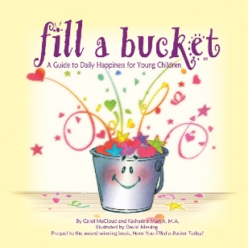
This 24-page picture book describes bucket filing only, with no mention of bucket dipping.

1st Grade: Have You Filled a Bucket Today?
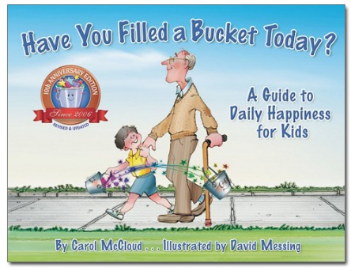
Also available in Spanish and French, this 32-page picture book describes bucket filling and bucket dipping. This book is appropriate to use for any age.

2nd Grade: Bucket Filling from A to Z
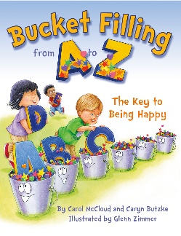
This rhyming, 32-page picture book shows many ways children can keep buckets filled.

3rd Grade: Buckets, Dippers, and Lids
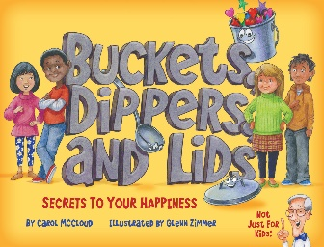
This 48-page "bridge" book (between a picture and chapter book) describes bucket filling, bucket dipping, and the lid.

3rd Grade and higher: Growing Up with a Bucket Full of Happiness
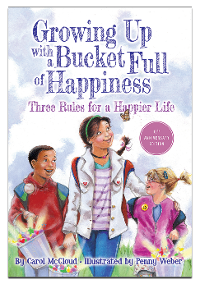
This 88-page chapter book explains the importance of bucket filling, not dipping, and using your lid for your bucket and others.

Classroom & School Grants Program is sponsored in part by a major grant from the
Consortium of Florida Education Foundations and:
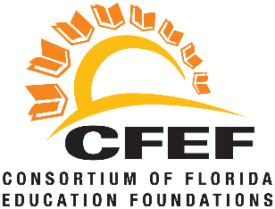
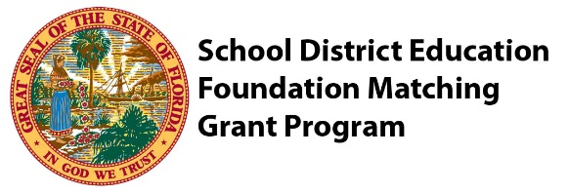

Classroom Grants Gold Sponsors
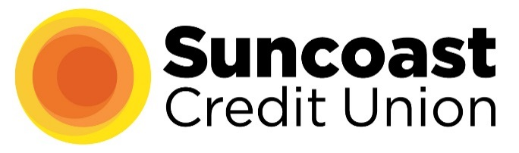
Classroom Grants Silver Sponsors
FineMark National Bank & Trust
Internet Essentials by Comcast
LCEC
Utilities Structures

Classroom Grants Bronze Sponsors
B&I Contractors
Marshall T. Bower, Esq.
Cape 912/Voice of the Constitution
Covanta
Edison National Bank/Bank of the Islands
Fort Myers Mighty Mussels
Gamma Zeta chapter of Alpha Delta Kappa
Lake Michigan Credit Union
Sanibel Captiva Community Bank
Mr. & Mrs. Kevin Shimp
Constance White-Davis

