Ready-2-Go Hydroponics Grant
Application 2021-2022
Instructions

Deadline: Monday, November 1, 2021 at 4 PM

Who May Apply

Any full-time Elementary teacher(s) (grades 3-5) currently employed by the School District of Lee County. While numerous grants may be awarded to teachers from the same school, only one grant will be awarded per qualifying teacher.

Applicants must attend one of the mandatory grant workshops held at The Foundation for Lee County Public Schools, 2266 Second Street, Fort Myers, FL. Please pre-register with Theresa Reich at Theresa@leeschoolfoundation.org for an available workshop date. Applications will be emailed to workshop attendees the following day.

Important Information

- An incomplete application will be disqualified.
- The completed application must be typed in an unlocked Word document and include the Application Cover Sheet and Blind Application.
- The school principal and applicant must both sign a hard copy of the Application Cover Sheet to verify that grant procedures will be followed.
- Completed applications (signatures not necessary) must be submitted by email (Theresa@leeschoolfoundation.org) no later than Monday, November 1, 2021 by 4 PM. An original hard copy, to include the signed Application Cover Sheet, must be sent by Pony to The Foundation office to be received by Monday, November 8, 2021.
- Applicants will be notified by early December whether or not their grant has been awarded.
- Any changes to the project must be pre-approved. Please email Beverly@leeschoolfoundation.org or Theresa@leeschoolfoundation.org for any changes.
- Equipment and supplies purchased with grant monies will remain the property of the school at which the grant was awarded. All items valued over $500.00, and with a life expectancy of over one year, must be tracked by the District’s Property & Records Department.
- Mid-year reports are due at The Foundation office by January 7, 2022.
- Project must be completed- no later than May 13, 2022.
- Final grant reports; including the evaluation, expense report, descriptive receipts and bookkeeper’s ledger; are due at The Foundation office by May 25, 2022.

Project Number
Do not complete. Foundation use only.

Ready-2-Go Hydroponics Grant Application
Cover Sheet 2021-2022

The application form is in an open Word document, and all answers must be typed in this document.
Submit an unlocked document. A non-typed or incomplete application will be disqualified.

Project Title: |  |  | STEM – Hydroponic Garden
Teacher/Team Leader’s Name: |  |  |  |  |  | Cell Phone:
School: |  |  |  |  |  |  | Grade Level(s):
School Email:
List other team members:

I hereby apply for a Ready 2 Go Hydroponic Garden Grant.
If awarded I would like to receive the following system: (Select one system-system options are listed at end of application) Remember to consider each system’s requirements before making your selection
___A-
___B-
___C-

I certify that I attended a mandatory workshop on _________________________, 2021.

Teacher’s Signature Date
*If Grade Level Grant, only Lead Teacher’s signature

I certify that this grant application has been reviewed and has my approval:

Administrator Name (printed)_________________________________________

Administrator Signature Date

Electronically submitted applications (Send to Theresa@leeschoolfoundation.org) MUST be received by:
Monday, November 1, 2021 by 4 PM
Submit original, signed hard copy to The Foundation via Pony by Friday, November 5, 2021
The Foundation for Lee County Public Schools Gwynne Institute, 2266 Second Street, Fort Myers, FL 33901

Project Number _____
Do not complete. Foundation use only.

Ready-2-Go Hydroponics Grant
Blind Application 2021-2022

DO NOT use any identifying information (your name or your school’s name) from this point forward.
Project Title: | Hydroponics
Grant Category & Focus: | STEM |  |  |  | Grade Level(s):
Number of Participating Students: |  |  |  | Number of Participating Low-Performers:
Hydroponic System Requested
(A, B, or C):

Please provide the following information in the order presented. This application is an open Word document and all answers must be typed in this document in the green box below each question. Other material will not be reviewed. INCOMPLETE APPLICATIONS WILL BE DISQUALIFIED. Judging is based on point values assigned to each section.

Project Overview
Growing plants hydroponically helps gardeners grow more food in smaller areas

When students grow plants hydroponically, they begin to investigate plant needs through a different lens and have the chance to develop a deep understanding about the conditions required for healthy plant growth and development.
Hydroponic gardening also offers the opportunity to explore foundational engineering and design principles.

Students will explore how they can provide support for plants without soil? How do plants grown with just water and nutrients compare with plants grown in soil? How can we get the tallest plants using a hydroponics setup?

Student will learn to do experimentation and problem-solving in the classroom. Recordkeeping becomes a natural outgrowth of these endeavors.

Students will learn concepts related to basic plant parts and needs, nutrition, food production, recycling, agricultural technology. Additionally, students will address classroom business opportunities and possible career opportunities.

Finally, they would summarize their findings and create multimedia displays to showcase their research at a Plant Presentation Family Workshop. Students will be instructors of this workshop and will teach participants about container gardening and individual hydroponic gardening and give seeds and materials needed to grow them at home after this workshop.
High school students from a hydroponics class will assist with the construction of the system, and the Lee County School Garden Network and master gardeners will provide technical assistance.

The purpose of this proposal is for students to explore alternative ways to produce food. The students will compare plants grown traditionally to those grown with hydroponic methods. Students will learn that hydroponic methods solve problems where water, soil and space are scarce, such as in a space station.

Culminating benefits will be when edible crops are grown and students experience the joy and excitement of sampling the fruits of their labor!

This project is intended to be ongoing and continue into subsequent years.

Project Goals and Objectives

The goal of this project is twofold:

- Using "Hydroponics How-to" and "We're the Producers" from Gardening for Grades curriculum, students will grow lettuce, tomatoes and herbs in hydroponic units to discover the end product of Photosynthesis--food! This project will further their understanding that a plant's food comes from the sun, not the soil. Students will compare the growth of the plants with those grown in a container or soil garden
- Low-achieving students will be more motivated to learn and practice skills that are related to an actual project. The multisensory approach linked with the pride of a long-term delicious result they share with their families will inspire them. They will get practice in applying the skills they learn and will remember them better as a result. Finally, they will gain confidence as they present the information they learn to others

Project Evaluation

To determine the success of this project, teachers will be provided with a retrospective survey. The survey will compare and contrast data of student understanding in several areas relating to the project, pre and post-project as well as classroom behavior, participation and parental involvement. The retrospective will be provided to the awarded teacher by the Foundation and must be completed no later than May 25, 2022.

Standards based goals to be achieved:
- Fourth and fifth grade students will draw a food chain including four trophic levels.
- Third through fifth grade students will explain photosynthesis.
- Students will describe the role of flowers in plant reproduction and students will explain the way plants' needs are met, & will list the steps to grow a seed.
- Third through fifth grade students will explain the use of hydroponics in Florida and other places (space). They will explain that technology is the solution for a problem.
- Parental involvement will increase due to the student led workshop for families.
- Students involved in projects will improve classroom behavior, completion of assignments, and have improved attendance compared to non-participating classes.

- Project Timeline (10 points)

Below is an example of a project timeline:

December research plants to grow and hydroponics; purchase supplies needed
January plant seedlings both traditionally and hydroponically
monitor, collect data, and maintain nutrient supplies.
February begin harvesting lettuce and other crops, continued data collection
Draw conclusions based on research.
March make multimedia presentations
April hold Plant Presentation event for public (students teach others what they have learned).

Using the example above as a rough outline, please reach out to Environmental Education to determine the details of your particular project and outline the project timeline you plan to use in the space below. It should include your plans to build or assemble the garden after receiving your items and should spell out how you plan to incorporate the garden into your lesson plans. If possible, your timeline should include a visit to see the garden for the Foundation and Sponsors. Please remember the project needs to be completed by May 13, 2022.

- Project Need (35 points): Please provide a paragraph to explain the reason why this project is needed for your school and why alternative funding is not available. (200 words or less)

- Project Outcomes (35 points): What outcomes do you hope to see for your students in addition to the goals/objectives indicated in the questions above? Please provide a paragraph to explain (200 words or less)

- Improving Practice: Please select an area of instructional practice (Classroom Environment or Instructional Delivery) and at least one of the sub-category listed under that area that you hope this project will help you develop as an instructor.

Areas of Instructional Practice: (select one Area and at least one sub category)

___Classroom Environment

Creating an environment of respect
Establishing a culture for learning
Establishing and managing classroom procedures
Stopping misconduct by using effective, appropriate techniques
Organizing physical space

___Instructional Delivery

Communicating with students
Using questioning and discussion techniques
Engaging students in learning
Using assessment in instruction
Demonstrating flexibility and responsiveness

In the space below, please explain how you believe this project will help you develop as an instructor in the area you selected above.

- Anything to add? (20 points):
In the space below, please provide any additional thoughts you would like to convey to the selection committee to build upon the questions above, i.e. participating business partners, ways to enhance the project, why creating unique learning experiences are important, etc.

Ready-2-Go Hydroponics Grant Options

Choose one of the following systems for your project. System A must be on behalf of 2 or more classrooms.
Systems B & C mau be for a single classroom. All systems will need direct sun.

System A Requirements: 2 or more classrooms, large space with electric and water available

Verti-Gro 10 Tower Hydroponic Garden KIt

- Includes towers, pots, media, fertilizer, plumbing, timer and pump.
- Needs electrical plug in and water source, and water reservoir container (55 gallon drum) (can be donated from Downtowner Car Wash.)
- Will come with free seeds

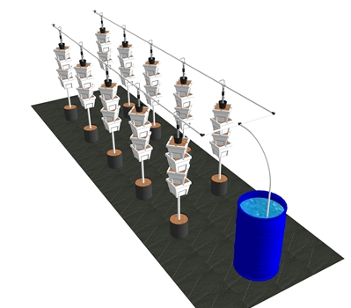

System B Requirements: 1 classroom, small space, mobile needs electric available

SMART Farm Solar Powered Automatic Recirculating Garden Tower
- Includes: 5 Large Stacking Planter,16 Gallon Reservoir, Heavy Duty Lid,
- 250 GPH Submersible Pump,7 Day Digital Timer, Water Distribution Head,
- Starter Plant Food, All Pipes,Tubes, Adapters,
- Growing Guide Online Chat Support
- Will come with free seeds

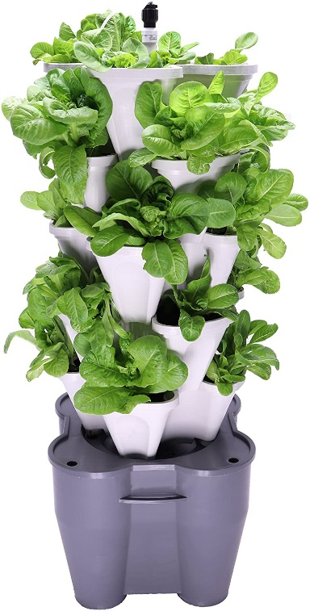

System C Requirements: 1 classroom, No electric, can be hand watered every other day.

Garden Tower 2 Mobile Composting Garden Tower

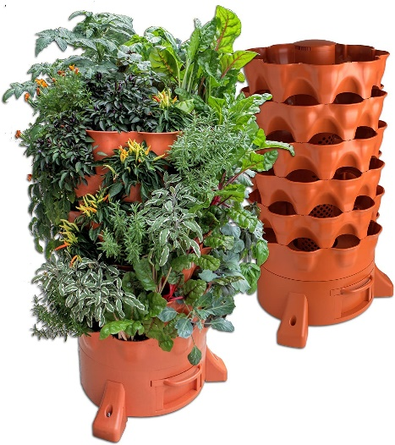
Includes: worms for interdependence, food chain lessons. No extra nutrients needed, as they come from compost placed inside

Movable with Dolly

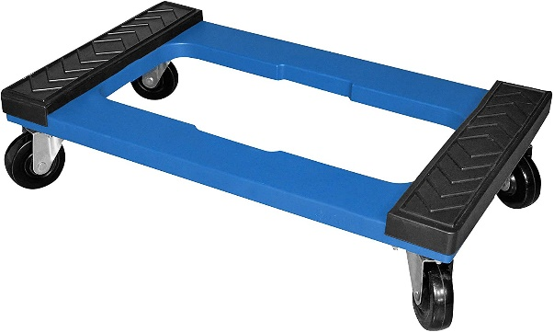

Classroom & School Grants Program is sponsored in part by a major grant from the
Consortium of Florida Education Foundations and:
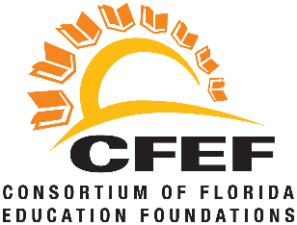

Classroom Grants Gold Sponsors

Classroom Grants Silver Sponsors
FineMark National Bank & Trust
Internet Essentials by Comcast
LCEC
Utilities Structures

Classroom Grants Bronze Sponsors
B&I Contractors
Marshall T. Bower, Esq.
Cape 912/Voice of the Constitution
Covanta
Edison National Bank/Bank of the Islands
Fort Myers Mighty Mussels
Gamma Zeta chapter of Alpha Delta Kappa
Lake Michigan Credit Union
Sanibel Captiva Community Bank
Mr. & Mrs. Kevin Shimp
Constance White-Davis

