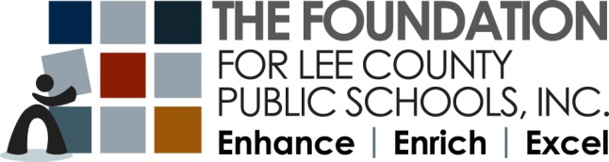

Ready-2-Go Music Grant
Application 2021-2022
Instructions

Deadline: Monday, November 1, 2021 at 4 PM

Who May Apply

Any full-time teacher(s) currently employed by the School District of Lee County, including Pre-K, Vocational, Technical, Media Specialists, School Counselors, and Coaches are eligible. While numerous grants may be awarded to teachers from the same school, only one grant will be awarded per qualifying teacher.

Applicants must attend one of the mandatory grant workshops held at The Foundation for Lee County Public Schools, 2266 Second Street, Fort Myers, FL. Please pre-register with Theresa Reich at Theresa@leeschoolfoundation.org for an available workshop date. Applications will be emailed to workshop attendees the following day.

Important Information

- An incomplete application will be disqualified.
- The completed application must be typed in an unlocked Word document and include the Application Cover Sheet and Blind Application.
- The school principal and applicant must both sign a hard copy of the Application Cover Sheet to verify that grant procedures will be followed.
- Completed applications (signatures not necessary) must be submitted by email (Theresa@leeschoolfoundation.org) no later than Monday, November 1, 2021 by 4 PM. An original hard copy, to include the signed Application Cover Sheet, must be sent by Pony to The Foundation office to be received by Monday, November 8, 2021.
- Applicants will be notified by early December whether or not their grant has been awarded.
- Any changes to the project must be pre-approved. Please email Beverly@leeschoolfoundation.org or Theresa@leeschoolfoundation.org for any changes.
- Equipment and supplies purchased with grant monies will remain the property of the school at which the grant was awarded. All items valued over $500.00, and with a life expectancy of over one year, must be tracked by the District’s Property & Records Department.
- Mid-year reports are due at The Foundation office by January 7, 2022.
- Project must be completed- no later than May 13, 2022.
- Final grant reports will be emailed to all awardees and are due at The Foundation office by May 25, 2022.

Project Number
Do not complete. Foundation use only.

Ready 2 Go Music Grant Application
Cover Sheet 2021-2022

The application form is in an open Word document, and all answers must be typed in this document.
Submit an unlocked document. A non-typed or incomplete application will be disqualified.

Project Title: |  |  | Music Makers - Instruments for All
Teacher/Team Leader’s Name: |  |  |  |  |  | Cell Phone:
School: |  |  |  |  |  |  | Grade Level(s):
School Email:
List other team members:

I hereby apply for a Ready 2 Go Music Grant
If awarded I would like to receive the following instrument package: (Select one package-options are listed at end of application) All Ready-2-Go Music Grants must be applied for on behalf of a school department
___Orff Ensemble
___Ukulele Ensemble
___World Drumming

I certify that I attended a mandatory workshop on _________________________, 2021.

Teacher’s Signature Date
*If Grade Level Grant, only Lead Teacher’s signature

I certify that this grant application has been reviewed and has my approval:

Administrator’s Name(printed)_____________________________________________________________

Administrator’s Signature Date

Electronically submitted applications (Send to Theresa@leeschoolfoundation.org) MUST be received by:
Monday, November 1, 2021 by 4 PM
Submit original, signed hard copy to The Foundation via Pony by Friday, November 5, 2021
The Foundation for Lee County Public Schools Gwynne Institute, 2266 Second Street, Fort Myers, FL 33901

Project Number _________
Do not complete. Foundation use only.

Ready-2-Go Music Grant
Blind Application 2021-2022

DO NOT use any identifying information (your name or your school’s name) from this point forward.
Project Title: | Music for the Masses- Instruments for All
Grant Category | Music/Arts |  |  |  | Grade Level(s):
Number of Participating Students: |  |  |  | Number of Participating Low-Performers:
Which Package are you applying for?
(Orff Ensemble, Ukulele Ensemble, or World Drumming)

Please provide the following information in the order presented. This application is an open Word document and all answers must be typed in this document in the green box below each question. Other material will not be reviewed.
INCOMPLETE APPLICATIONS WILL BE DISQUALIFIED. Ranking is based on point values assigned to each section.

Project Overview
To ensure that each of our students reaches his/her highest academic and personal potential, we are committed to continuously improving the learning of our students through the arts. This, according to the research, has a positive effect on increasing levels of achievement, personal growth and success in all academic areas. "Students who learned to play a musical instrument in elementary and continued playing in high school, not only score significantly higher but were about one academic year ahead of their non-music peers with regard to their English, mathematics and science skills.” (Gouzouasis, Guhn, 2019) Over 40% of our student body is at risk according to the diagnostic I ready data for ELA. In math 39% of the students are at risk as well. As a school, we are addressing this challenge in various ways. Utilization of the MTSS protocol, Differentiated and various learning strategies including Kagan, etc.
This project will establish either a ukulele ensemble, an Orff ensemble or drum circle. The grant funds will be used to purchase instruments to assist in the ongoing learning of music theory, including but not limited to dynamics, music vocabulary, reading music, time signature, rhythmic structures, and chord progressions
This project is intended to be ongoing and continue into subsequent years.

Project Goals and Objectives

It is the goal of this project to address motivation and produce an intrinsic value system that will promote higher level thinking and subsequently higher performance on tests. Research shows that as students learn the language of music, there will be a gradual increase in achievement in their other subjects as well.

Project Evaluation

(The following evaluation DOES NOT need to be completed for your application. It is provided here for informational purposes. If awarded, you will receive the appropriate rubric as a google form retrospective. You DO NOT need to complete the assessment at this time.

Ukulele Ensemble Rubric
Use the following rubric to assess the extrinsic musical instrument learning goals for the Ukulele Ensemble Project.
Assessment Category | 4 | 3 | 2 | 1
Chord Accuracy & Knowledge | All my chords and fingering are correct. | Most of the chords can be heard clearly. | Some of my chords are clear. I am having trouble with some of the fingering. | I struggle with most or all of the chords and fingering.
Strumming | Strumming is consistent and rhythm works for the song. | Strumming is consistent most of the time and rhythm works for the song. | Strumming is somewhat consistent, and rhythm works for some of the song. | Strumming is not consistent, and rhythm does not work for the song.
Posture | Holds Ukulele against chest with pegs facing upward. Fingers are curved properly. | Holds Ukulele against chest with pegs facing upward. Fingers are somewhat curved properly. | May or may not hold Ukulele against chest with pegs facing upward. Fingers are not curved properly. | Student does not hold Ukulele properly.
Practice & Participation | Student effort (rehearsal and performance) is excellent. | Student effort (rehearsal and performance) is good. | Student effort (rehearsal and performance) is fair. | Student effort (rehearsal and performance) is poor.

Orff Ensemble/World Drumming Rubric
Use the following rubric to assess the extrinsic musical instrument learning goals for the
Orff Ensemble or World Drumming project
Assessment Category | 4 | 3 | 2 | 1
Maintains a Steady Beat | Always maintains a steady beat. | Usually maintains a steady beat. | Occasionally maintains a steady beat. | Rarely maintains a steady beat.
Plays Patterns Correctly | Always plays patterns correctly. | Usually plays patterns correctly. | Occasionally plays patterns correctly. | Rarely plays patterns correctly.
Stays with the Ensemble While Playing | Always stays with the ensemble while playing. | Usually stays with the ensemble while playing. | Occasionally stays with the ensemble while playing. | Rarely stays with the ensemble while playing.
Can Maintain an Independent Part | Always can maintain an independent part. | Usually can maintain an independent part. | Occasionally can maintain an independent part. | Rarely can maintain an independent part.

Please complete all questions from this point on. Remember – Do NOT include any identifying information about you or the school you teach at.

- Project Timeline (10 points)
Below is an example project timeline:
Week 1: Introduction to the Ukulele Tuning the strings. Listening to some basic Hawaiian songs.
Week 2: The C Chord: Proper fingering techniques, Posture, Hand Positioning; Basic strumming.
Week 3: F Chord, Review C Chord; Strumming techniques, My first Uke song. (Yellow Submarine?)
Week 4: C7 & A minor chords: Students practice chords (C, F, C7 & Am).
Week 5: (February) G Chord; Jamaican Culture 3 Little Birds
Week 6: A Chord, Review: C, G, F, C7, Am Learn A Note & C note.
Week 7: E Note, Review Chords C, G, F, C7
Week 8: (March) Students Learn B Note, F Note & G Note, Discussion about culminating activity.
Week 9: E minor; Somewhere over the Rainbow (C, Em, F, C, Am, G) By Israel Kamakawiwo’ole
Week 10: A look at Hawaiian Ukulele songs. Students decide songs for the culminating activity
Week 11-17: Practice Songs for culminating activity (concert, show, etc.)

Using the above example as a reference, please detail the project timeline you plan to use below. Be sure to incorporate your curriculum. Please reach out to your District Fine arts/Performing Arts Coordinator for curriculum assistance if needed. Your final grant proposal will need to have the timeline you plan to use. Your project should include a culminating event of some sort and needs to be completed by May 13, 2022.

- Project Need (35 points): Please provide a paragraph to explain the reason why this project is needed for your school and why alternative funding is not available. (200 words or less)

- Project Outcomes (35 points): What outcomes do you hope to see for your students in addition to the goals/objectives indicated in the questions above? Please provide a paragraph to explain (200 words or less)

- Improving practice: Please select an area of instructional practice (Classroom Environment or Instructional Delivery) and at least one of the sub-categories listed under that area that you hope this project will help you develop as an instructor.

Areas of Instructional Practice: (select one Area and at least one sub category)

___Classroom Environment

Creating an environment of respect
Establishing a culture for learning
Establishing and manages classroom procedures
Stopping misconduct by using effective, appropriate techniques
Organizing physical space

___Instructional Delivery

Communicating with students
Using questioning and discussion techniques
Engaging students in learning
Using assessment in instruction
Demonstrating flexibility and responsiveness

In the space below, please explain how you believe this project will help you develop as an instructor in the area you selected above.

- Anything to add? (20 points)
In the space below, please provide any additional thoughts you would like to convey to the selection committee to build upon the questions above, i.e. participating business partners, ways to enhance the project, why creating unique learning experiences are important, etc.

Ready-2-Go Music Grant Package Options
Requirements – must be applied for on behalf of a school department

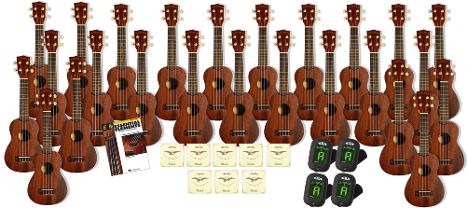
Instrument Package A - Ukulele Ensemble
4-Soprano/Concert Ukulele Strings (clear fluorocarbon) Martin
4-Clip-On Chromatic Tuner Snark
25-Soprano Ukulele Kohala

Instrument Package B - Orff Ensemble
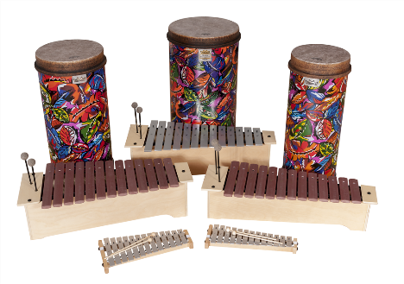
1-14" Pre-Tuned Tubano Remo
1-12" Pre-Tuned Tubano Remo
1-10" Pre-Tuned Tubano Remo
1-Alto Xylophone Sonor
1-Soprano Xylophone Sonor
1-Alto Metallophone Sonor
1-Alto Glockenspiel Sonor
1-Soprano Glockenspiel

Instrument Package C - World Drumming
3 -10" tubanos
7 - 12" tubano
3 - 14" tubano
1 - 12" tunable djembe
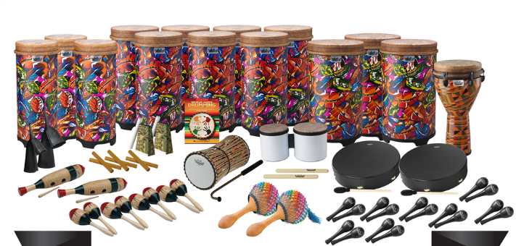
1 - Remo talking drum
1 - Remo talking drum mallet
2 - 16" Bahia Buffalo Drum
1 - Bongos
8 - Mini Maracas
2 - Guiros
3 - Claves
4 - Maracas
1 - Medium Gankogui
1 - Large Gankogui
2 – Shakere, Axaste
2 - 5.5" Acousti-Blox
1 - World Music Drumming

Classroom & School Grants Program is sponsored in part by a major grant from the
Consortium of Florida Education Foundations and:
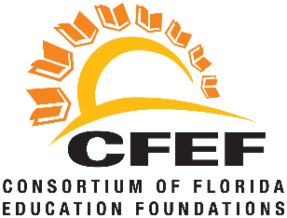
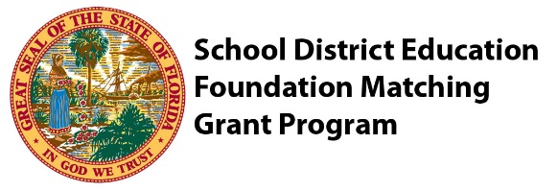

Classroom Grants Gold Sponsors
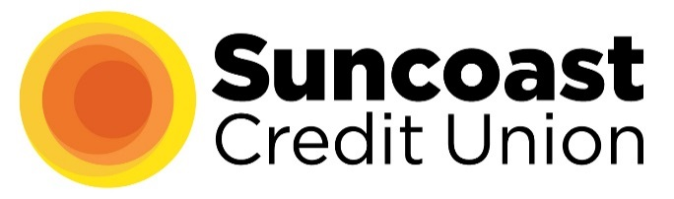
Classroom Grants Silver Sponsors
FineMark National Bank & Trust
Internet Essentials by Comcast
LCEC
Utilities Structures

Classroom Grants Bronze Sponsors
B&I Contractors
Marshall T. Bower, Esq.
Cape 912/Voice of the Constitution
Covanta
Edison National Bank/Bank of the Islands
Fort Myers Mighty Mussels
Gamma Zeta chapter of Alpha Delta Kappa
Lake Michigan Credit Union
Sanibel Captiva Community Bank
Mr. & Mrs. Kevin Shimp
Constance White-Davis

