Ready-2-Go Sensory Room Grant
Application 2021-2022
Instructions

Deadline: Monday, November 1, 2021 at 4 PM

Who May Apply

Any full-time teacher(s) currently employed by the School District of Lee County, including Pre-K, Vocational, Technical, Media Specialists, School Counselors, and Coaches are eligible. While numerous grants may be awarded to teachers from the same school, only one grant will be awarded per qualifying teacher.

Applicants must attend one of the mandatory grant workshops held at The Foundation for Lee County Public Schools, 2266 Second Street, Fort Myers, FL. Please pre-register with Theresa Reich at Theresa@leeschoolfoundation.org for an available workshop date. Applications will be emailed to workshop attendees the following day.

Important Information

- An incomplete application will be disqualified.
- The completed application must be typed in an unlocked Word document and include the Application Cover Sheet and Blind Application.
- The school principal and applicant must both sign a hard copy of the Application Cover Sheet to verify that grant procedures will be followed.
- Completed applications (signatures not necessary) must be submitted by email (Theresa@leeschoolfoundation.org) no later than Monday, November 1, 2021 by 4 PM. An original hard copy, to include the signed Application Cover Sheet, must be sent by Pony to The Foundation office to be received by Monday, November 8, 2021.
- Applicants will be notified by early December whether or not their grant has been awarded.
- Any changes to the project must be pre-approved. Please email Beverly@leeschoolfoundation.org or Theresa@leeschoolfoundation.org for any changes.
- Equipment and supplies purchased with grant monies will remain the property of the school at which the grant was awarded. All items valued over $500.00, and with a life expectancy of over one year, must be tracked by the District’s Property & Records Department.
- Mid-year reports are due at The Foundation office by January 7, 2022.
- Project must be completed- no later than May 13, 2022.
- Final grant reports; including the evaluation, expense report, descriptive receipts and bookkeeper’s ledger; are due at The Foundation office by May 25, 2022.

Project Number
Do not complete. Foundation use only.

Ready-2-Go Sensory Room Grant
Application
Cover Sheet 2021-2022

The application form is in an open Word document, and all answers must be typed in this document.
Submit an unlocked document. A non-typed or incomplete application will be disqualified.

Project Title: |  |  | Making Sense - Sensory Room
Teacher/Team Leader’s Name: |  |  |  |  | Cell Phone:
School: |  |  |  |  |  | Grade Level(s):
School Email:
List other team members:

I hereby apply for a Ready 2 Go Sensory Room Grant.
If awarded I would like to receive package: (Select one package- package options are listed at end of this application) Must be applied for on behalf of a Grade Level or School Department
___A-
___B-
___C-

I certify that I attended a mandatory workshop on _________________________, 2021.

Teacher’s Signature Date
*If Grade Level Grant, only Lead Teacher’s signature

I certify that this grant application has been reviewed and has my approval:

Administrator’s Name ( Printed)____________________________________________________________

Administrator’s Signature Date

Electronically submitted applications (Send to Theresa@leeschoolfoundation.org) MUST be received by:
Monday, November 1, 2021 by 4 PM
Submit original, signed hard copy to The Foundation via Pony by Friday, November 5, 2021
The Foundation for Lee County Public Schools Gwynne Institute, 2266 Second Street, Fort Myers, FL 33901

Project Number _____
Do not complete. Foundation use only.

Ready-2-Go Sensory Room Grant
Blind Application 2021-2022

DO NOT use any identifying information (your name or your school’s name) from this point forward.
Project Title: | Making Sense – Sensory Room
Grant Category & Focus: | Health/Fitness & Nutrition |  |  |  | Grade Level(s):
Number of Participating Students: |  |  |  | Number of Participating Low-Performers:
Sensory Package Requested
(A, B, or C):

Please provide the following information in the order presented. This application is an open Word document and all answers must be typed in this document in the green box below each question. Other material will not be reviewed. INCOMPLETE APPLICATIONS WILL BE DISQUALIFIED. Judging is based on point values assigned to each section.

Project Overview

With the rise in the number of students receiving services under the educational criteria for an autism spectrum disorder, it is critical that the Lee County School District increase their ability to provide services for those children. Most students that have followed a neurotypical developmental pattern are able to process their environment effectively, however most students with autism spectrum disorders need alternative strategies incorporated into their day to best process the world they live in.

Students with autism spectrum disorders have extreme sensory needs that make it difficult to stay on task and display appropriate classroom behavior. In a sensory regulation study, Gomez and Baird 2005, indicate that 86% of children were described to have had sensory differences that impacted them daily. If individual sensory needs are not identified and managed proactively and reactively throughout the school day, students with autism spectrum disorders may not be participating in daily school activities to their full extent. Identification of needs, understanding the differences and creating a more sensory appropriate environment may help students with autism spectrum disorders access the curriculum and social components to education more readily.

The purpose of this proposal is to create or enhance a sensory room to assist students with sensory needs, such as those with autism spectrum disorders, access their curriculum and social environment more readily.

This project is intended to be ongoing and continue into subsequent years.

Project Goals and Objectives

It is the goal of the project to benefit children with autism spectrum disorders by increasing their ability to participate in the least restrictive environment within their educational setting. This proposal will also help families and educational staff better understand sensory differences while being equipped with tools and strategies to support the unique differences these children with autism spectrum disorders face on a daily basis.

Project Evaluation

To determine the success of this project, teachers will be provided with a retrospective of unassisted "on task" behavior of students during several academic tasks (reading, listening, test taking, independent work). The retrospective will compare and contrast data of “on task” time, pre and post-consistent use of the sensory room to determine the amount of increase in “on task” behavior. The retrospective will be provided to the awarded teacher by the Foundation and must be completed no later than May 25, 2022.

- Project Timeline (10 points)

Below is an example of a project timeline:
January 2022: Receive Items
January 2022: Install, assemble items
January 2022: Schedule ‘Sensory room” time into class schedule
February2022: Observe and make notes of student’s unassisted on task time in reading,
listening, independent work and test taking work
February 2022: Begin using sensory room on a daily basis
March 2022: Continue to use sensory room consistently
April 2022: Invite Foundation and Sponsors to visit sensory room
May 2022: Complete retrospective as provided by Foundation
May 2022: Complete and return final report to Foundation

Using the example above as a rough outline, please detail the project timeline you plan to use below. It should include your plans to build or assemble the room after receiving your items and should spell out how you plan to incorporate use of the room into your class schedule. If possible, your timeline should include a visit to see the room for the Foundation and Sponsors. Please remember the project needs to be completed by May 13, 2022.

- Project Need: (35 points)Please provide a paragraph to explain the reason why this project is needed for your school and why alternative funding is not available. (200 words or less)

- Project Outcomes: (35 points) What outcomes do you hope to see for your students in addition to the goals/objectives indicated in the questions above? Please provide a paragraph to explain (200 words or less)

- Improving Practice: Please select an area of instructional practice (Classroom Environment or Instructional Delivery) and at least one of the sub-category listed under that area that you hope this project will help you develop as an instructor.

Areas of Instructional Practice: (select one Area and at least one sub category)

___Classroom Environment

Creating an environment of respect
Establishing a culture for learning
Establishing and managing classroom procedures
Stopping misconduct by using effective, appropriate techniques
Organizing physical space

___Instructional Delivery

Communicating with students
Using questioning and discussion techniques
Engaging students in learning
Using assessment in instruction
Demonstrating flexibility and responsiveness

In the space below, please explain how you believe this project will help you develop as an instructor in the area you selected above.

- Anything to add? (20 points)
In the space below, please provide any additional thoughts you would like to convey to the selection committee to build upon the questions above, i.e. participating business partners, ways to enhance the project, why creating unique learning experiences are important, etc.

 | Package A
 | Playlearn Fiber Optic Lamp
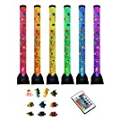 | Lightahead Extra Large 4 FT LED Fantasy Bubble Fish
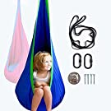 | Harkla Sensory Swing for Kids
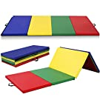 | Giantex 4'x10'x2'' Gymnastics Mat
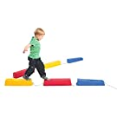 | edxeducation Step-a-Logs -
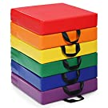 | HONEY JOY 6PCS Floor Cushions for Kids
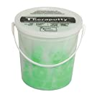 | Cando Plus Antimicrobial Theraputty Green 5 lb
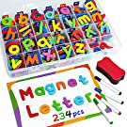 | Coogam Magnetic Letters Numbers 234 Pcs ,
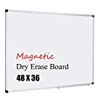 | XBoard Magnetic Whiteboard 48 x 36,
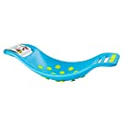 | Fat Brain Toys Teeter Popper,
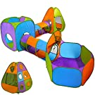 | Playz 5-Piece Kids Pop up Play Tent Crawl Tunnel and Ball Pit
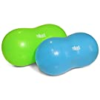 | Milliard Peanut Ball Variety Pack -
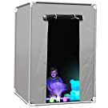 | Playlearn Blackout Sensory Tent –
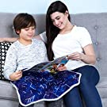 | Florensi 5 Lbs Weighted Lap Pad for Kids (20"x23"),
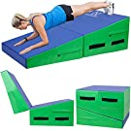 | HALEDAZE 48"×24"×14" Folding Gymnastics Wedge
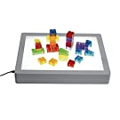 | Excellerations LED Light Box,
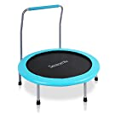 | SereneLife 36" Inch Portable Fitness Trampoline –
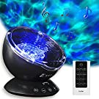 | Ocean Wave Projector and Sound Machine
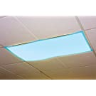 | Educational Insights The Original Fluorescent Light Filters
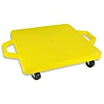 | Champion Sports Standard Scooter Board with Handles
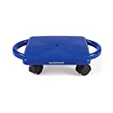 | hand2mind Blue Indoor Scooter Board with Safety Handles for Kids Ages 6-12, Plastic Floor Scooter Board with Rollers, Physical Education for Home, Homeschool Supplies (Pack of 1)  Offered by Amazon.com.
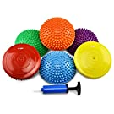 | Yes4All 3 Shapes Hedgehog Balance Pods and Balance Disc,
 | Sanho Yopo Dynamic Movement Sensory Sox, Large
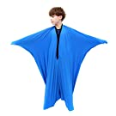 | Sanho Yopo Dynamic Movement Sensory Sox, Medium
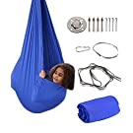 | Therapy Swing for Kids
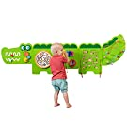 | LEARNING ADVANTAGE Crocodile Activity Wall Panels -
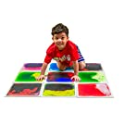 | Art3d Liquid Fusion Activity Play Centers
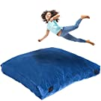 | Milliard Crash Pad, Sensory Pad
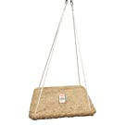 | Platform Swing -

 | Package B | Comments | Price | Quantity | Has
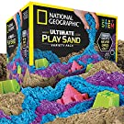 | NATIONAL GEOGRAPHIC Play Sand Combo Pack |  | $27.99 | 1 | 0
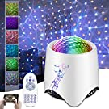 | Night light Projector for Kids, |  | $35.99 | 1 | 0
 | Playlearn Blackout Sensory Tent – |  | $220.00 | 1 | 0
 | Sanho Yopo Dynamic Movement Sensory Sox, Large |  | $28.96 | 2 | 0
 | Sanho Yopo Dynamic Movement Sensory Sox, Medium, |  | $26.99 | 2 | 0
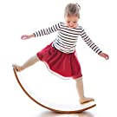 | Wooden Wobble Balance Board, |  | $69.99 | 2 | 0
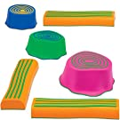 | edxeducation Step-a-Trail - 6 Piece Obstacle Course for Kids |  | $69.99 | 1 | 0
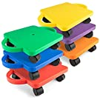 | Champion Sports Scooter Board with Handles, Set of 6, |  | $82.31 | 1 | 0
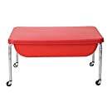 | Children's Factory 18" Large Sensory Table & Lid Set, |  | $154.99 | 1 | 0
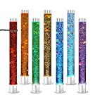 | Playlearn 4 Foot LED Sensory Bubble Tube Lamp |  | $145.99 | 1 | 0
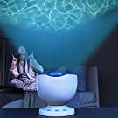 | Calming Autism Sensory LED Light Projector |  | $37.90 | 1 | 0
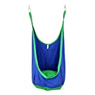 | Fun and Function - Cocoon Climbing Swing - |  | $106.99 | 2 | 0
 | SereneLife 36" Inch Portable Fitness Trampoline |  | $60.68 | 2 | 0
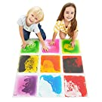 | Special Supplies Square Floor Liquid Tiles for Kids, Set of 9, |  | $149.90 | 1 | 0
 | Milliard Crash Pad, Sensory Pad |  | $179.99 | 1 | 0
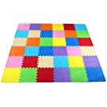 | BalanceFrom Kid's Puzzle Exercise Play Mat |  | $45.62 | 1 | 0
 | Matladin 24"x26" Gymnastics Octagon |  | $147.99 | 1 | 0
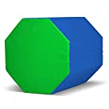 | Matladin 24"x26" Gymnastics Octagon |  | $151.99 | 1 | 0
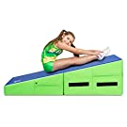 | C-CHAIN Sports Folding Gymnastics Cheese Mat Gym |  | $131.99 | 1 | 0
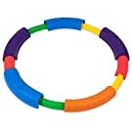 | SUNNY & FUN 12pc Balance Beam for Kids |  | $59.99 | 1 | 0
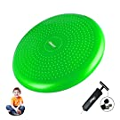 | Freesty Wobble Cushion, Wiggle Seat |  | $15.45 | 5 | 0
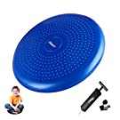 | Freesty Wobble Cushion, Wiggle Seat

Package C

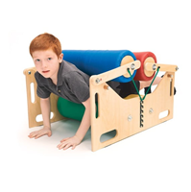 | Autism Steam Roller for neurological processing disorders |  | $17.99 | 1 | 0
 |  | Price | Quantity | Has
 | 2Pcs LED Colourful Changing Fibre Fiber Optic Light |  | $17.99 | 1 | 0
 | Playlearn Blackout Sensory Tent |  | $220.00 | 1 | 0
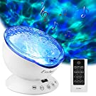 | Exelme Night Light Projector |  | $27.99 | 1 | 0
 | Coogam Magnetic Letters Numbers 234 Pcs |  | $23.98 | 1 | 0
 | XBoard Magnetic Whiteboard 48 x 36, |  |  | 1 | 0
 | hand2mind Blue Indoor Scooter Board with Safety Handles |  | $24.29 | 4 | 0
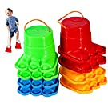 | IROO Balancing Stilts for Kids, |  | $27.99 | 1 | 0
 | Balance Beam Stepping Stones Gymnastics Obstacle Course Balance |  | $119.99 | 1 | 0
 | Cando Plus Antimicrobial Theraputty Green 5 lb |  | $89.26 | 1 | 0
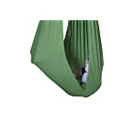 | SENSORY4U Indoor Therapy Sensory Swing |  | $44.95 | 1 | 0
 | BalanceFrom Kid's Puzzle Exercise Play Mat |  | $45.62 | 1 | 0
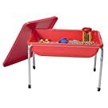 | Children’s Factory Large Sensory Table and Lid Set, 36” by 24 |  | $151.46 | 1 | 0
 | NATIONAL GEOGRAPHIC Play Sand Combo Pack |  | $27.99 | 1 | 0
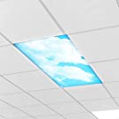 | Educational Insights Calming Clouds Light Filters 4-Pack |  | $36.99 | 2 | 0
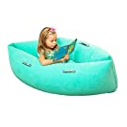 | Bouncyband Small Comfy Peapod Sensory Pad - Green 48 |  | $99.99 | 1 | 0
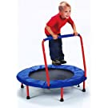 | The Original Toy Company Fold & Go Trampoline |  | $89.95 | 1 | 0
 | Milliard Crash Pad,. |  | $179.99 | 1 | 0
 | Platform Swing - |  | $149.99 | 1 | 0
 | Playlearn 4 Foot LED Sensory Bubble Tube Lamp

Classroom & School Grants Program is sponsored in part by a major grant from the
Consortium of Florida Education Foundations and:
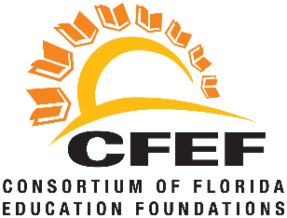

Classroom Grants Gold Sponsors

Classroom Grants Silver Sponsors
FineMark National Bank & Trust
Internet Essentials by Comcast
LCEC
Utilities Structures

Classroom Grants Bronze Sponsors
B&I Contractors
Marshall T. Bower, Esq.
Cape 912/Voice of the Constitution
Covanta
Edison National Bank/Bank of the Islands
Fort Myers Mighty Mussels
Gamma Zeta chapter of Alpha Delta Kappa
Lake Michigan Credit Union
Sanibel Captiva Community Bank
Mr. & Mrs. Kevin Shimp
Constance White-Davis

